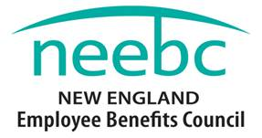
2015 Rising Star Award
Nomination Form
The new Rising Star Award is intended for someone fairly new to the profession who has demonstrated exceptional promise, dedication and accomplishment. If you know someone, please nominate them today.
Email the Form to Patty@neebc.org by September 23rd, or call 781.684.8700 for more information.
Eligibility:
Nominations from NEEBC members and non-member organizations will be considered.
Criteria (should meet most criteria):
- Strong commitment to the Employee Benefits industry
- Dedication
- Professionalism
- Potential future leader
- Worked on a program, project, system, innovation or idea that resulted in a positive impact to their organization
- Strong commitment to professional development
- Professional success as measured by the organization
Recognition:
- Recognition at NEEBC’s Best Practices Conference in December 2015
- Crystal Award
- Photo and press release
- Complimentary one year membership in NEEBC
Please use the form below to nominate your candidate for the NEEBC Rising Star Award.
Deadline for nominations is September 23rd. Winner will be notified in November.

Please complete the information on the next page.

Email this Form to Patty@neebc.org by September 23rd, or call 781.684.8700 for more information.
I think the individual named below should receive this award for the following reasons:

Your Name * |  | Your Title*
Your Organization's Name *
Your Phone # * |  | Your E-mail *
Nominees' Name *
Nominees' Title *
Nominees' Organization *
Nominees' Phone * |  | Nominees' E-mail *
______________
*Required Fields

